(Approx. 682 words)

Finding Ghosts In Your Computer
by Mike Morris, Editor, Front Range PC Users Group,
http://www.frpcug.org
twriterext(at)gmail.com

Obtained from APCUG with the author's permission for publication by APCUG member groups.

You think I am kidding? The Microsoft Knowledgebase article on this subject refers to “…”ghosted” devices…” and “Phantom devices….”

Before we get started with an explanation, four facts need to be identified:

- I owe a thank you to fellow Front Range PC Users Group member Howard Norlin for suggesting this article.

- This article is based on the Microsoft Knowledgebase Article ID 315539 for Windows XP Home and Professional. Connect to http://support.microsoft.com/search/ to locate the article. Enter the article number, 315539, into the search field and GO. The article has the long title of: “Device Manager does not display devices that are not connected to the Windows XP-based computer.”

- Under the “STATUS” heading of this article, you will find this statement: “This behavior is by design.” [Ed. Note: that means that “(t)his behavior…” is a feature, not a bug].

- Yes, I am aware of the famous movie about finding and destroying ghosts. Even I am aware of that movie and I haven’t been to a movie in a theater in decades. I decided not to use the movie title in this article in order to avoid any potential copyright conflict.

The Device Manager feature in Windows can be used for several purposes. Perhaps one of the best known uses is troubleshooting. Here is one method of obtaining access to Device Manager, using a series of mouse clicks:

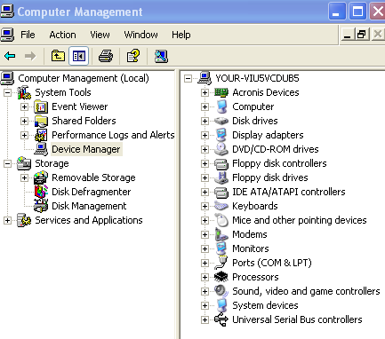
Click on Start/Click on Control Panel/Double click on Administrative Tools/Double click on Computer Management. Then, under System Tools, click on Device Manager. A list of device categories is displayed:

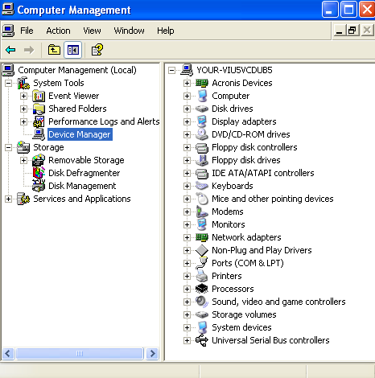
It may not be obvious at first glance, but not everything is displayed that you might expect. On the Computer Management Menu Bar, click on View, then on "Show hidden devices.” Examine the result:

Look carefully, and you will see the “Printers” category has been added.

One may speculate—and debate—why the printer category is classified as a “hidden” device. The point is, selecting the “Show hidden devices” option still does NOT provide a complete list of hardware or software items that are—or have been—connected to the computer. That result is the origin of the phrase “ghosted devices.”

Why should you care?

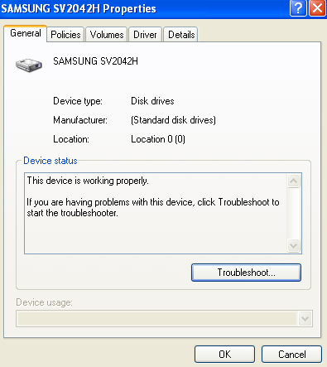
Perhaps for the majority of users, knowledge of this issue is not critical. However, as mentioned earlier, Device Manager can be used as a troubleshooting aid. For example, if I click on the + sign to the left of Disk Drives listed in the right panel of Device Manager, and then double click on the device displayed, a device-specific window is displayed.

The window offers several options for troubleshooting a malfunctioning device.

If the malfunctioning device is not listed when the “Show hidden devices” option is selected, it is time to use the procedure described in the article 315539. Note that the article makes reference to USB devices and docking stations for laptop computers.

There is another type of “ghost’ revealed when using the procedure described in the Microsoft article. If you have been using your computer for any reasonable length of time, the probability is high that you have installed/uninstalled hardware and software since the original purchase. Using the “show_non_present_devices” command will reveal leftover drivers that were not (but should have been) removed during the uninstall process—“ghosts” hiding in your computer.

It is time to answer the two questions I am certain everybody has:

- Q: Did I try the procedure?
- A: Yes.

- Q: Did I find any “ghosts”?
- A: Yes. I found a driver from a virus protection software package I uninstalled a long time ago. It was listed under the “Non-Plug and Play Drivers” category.

I wonder if I can now join the ranks of “Ghost B______.” There—I (almost) said it.

This article has been provided to APCUG by the author solely for publication by APCUG member groups. All other uses require the permission of the author (see e-mail address above).

